3D Bioprinting Solutions - Moscow, 05.02.2018
Data, derived from the world’s first space biofabrication experiment, shows promising results.
We obtained the data required to test formative production bioprinting technology in space experiment during ISS Expedition 57. The results demonstrate that the technology we have developed enables the fabrication of three-dimensional living tissue engineering and organ structures with the use of low concentrations of paramagnetic materials, significantly reducing the possible toxic effect of the latter on cell viability.
The ISS crew conducted all stages of the experiment in accordance with the onboard documentation. An analysis of photos and videos taken on the ISS showed the gradual fabrication of the constructs in natural microgravity.

Once we received samples back on Earth, we performed a histological evaluation of the three-dimensional constructs collected from the tissue spheroids.
The histological analysis of tissue constructs shows that the cells inside the printed constructs are alive and have a typical morphology.

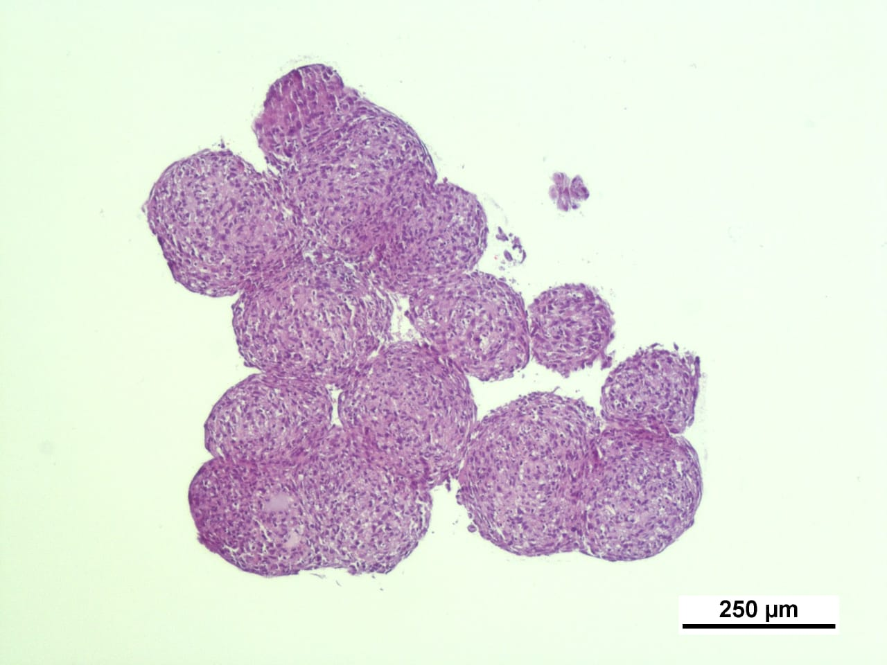

Data from the experiment confirmed the performance capabilities of the equipment and proved the feasibility of using three-dimensional magnetic bioprinting, which employs a magnetic field instead of a traditional solid biodegradable substrate "field". The magnetic bio-printer opens up new technological possibilities in the study of the physiology of tissue-engineered constructs, as well as enabling the printing of the complex structure of human organ constructs in natural microgravity in space. A further achievement was the development of a unified technology platform for various biotechnical studies based around the Russian segment of the ISS, including the possible use of crystals of inorganic and organic compounds in space microgravity fabrication, as well as bacterial biofilms.

..........

About 3D BIOPRINTING SOLUTIONS

3D Bioprinting Solutions is a laboratory for biotechnological research, which develops and produces bioprinters and materials for 3D bioprinting and also develops innovative biofabrication technologies. The 3D Bioprinting Solutions Laboratory was officially opened on September 6, 2013.
The company has international partners, cooperates with the leading institutes in Russia as well as scientists from renowned centers abroad. The laboratory has gathered a team of international, multi-disciplinary researchers, world-class scientists and engineers. Vladimir Mironov, Professor of the Department of Chemical and Life Science Engineering at Virginia Commonwealth University (USA), and recognized as one of the pioneers of robotic biofabrication, is the laboratory’s Head of Research.
To learn more go to https://bioprinting.ru/en
Press Contact:
Grigoriy Shalunov
+7 (926) 952 77 94
gregshalunov@bioprinting.ru

